Test Log
Test Reference: | 1 | Name of Tester: | Archie Tippett |  |  | Date of Test: | 06.10.2026
Purpose of Test: | Can the user select an item from the <<Music>> list, and then add them to an order?
Test Type: | Functional |  |  | User Requirement Tested: | 1
Test Instructions: | Attempt to add items from <<Music>> to an order by clicking on them.
Expected Outcome: | Items are added to the order.
Actual Outcome: | Works as expected.
Pass/Fail/Skipped: | Pass.
Comments and/or
Recommendations:
Evidence:
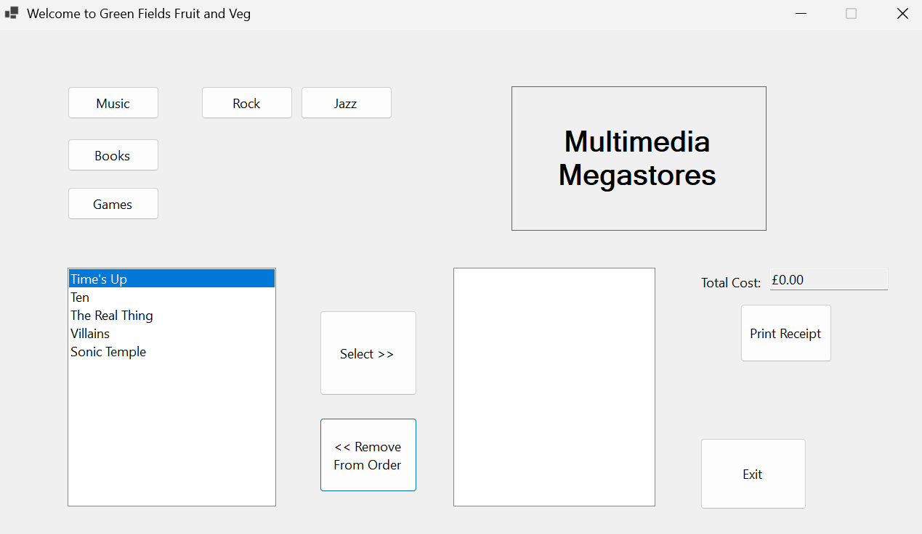
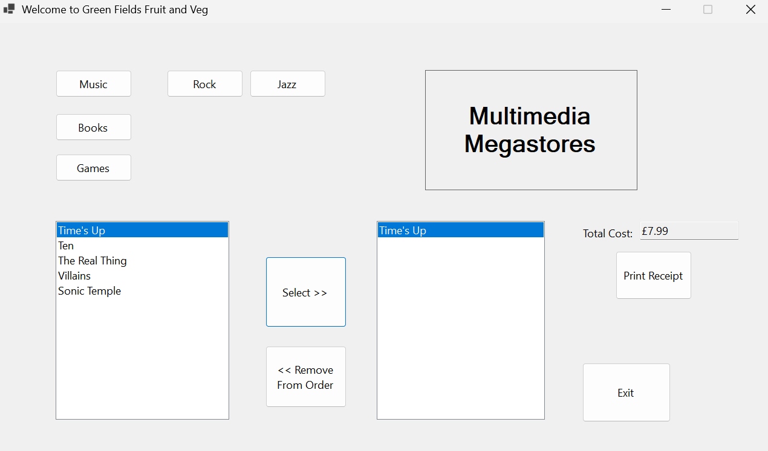

Test Reference: | 2 | Name of Tester: | Archie Tippett |  |  | Date of Test: | 06.10.2026
Purpose of Test: | Can the user select an item from the <<Book>> list, and then add them to an order?
Test Type: | Functional |  |  | User Requirement Tested: | 2
Test Instructions: | Can the user select an item from the <<Book>> list, and then add them to an order?
Expected Outcome: | Items are added to the order.
Actual Outcome: | Works as expected.
Pass/Fail/Skipped: | Pass.
Comments and/or
Recommendations:
Evidence:
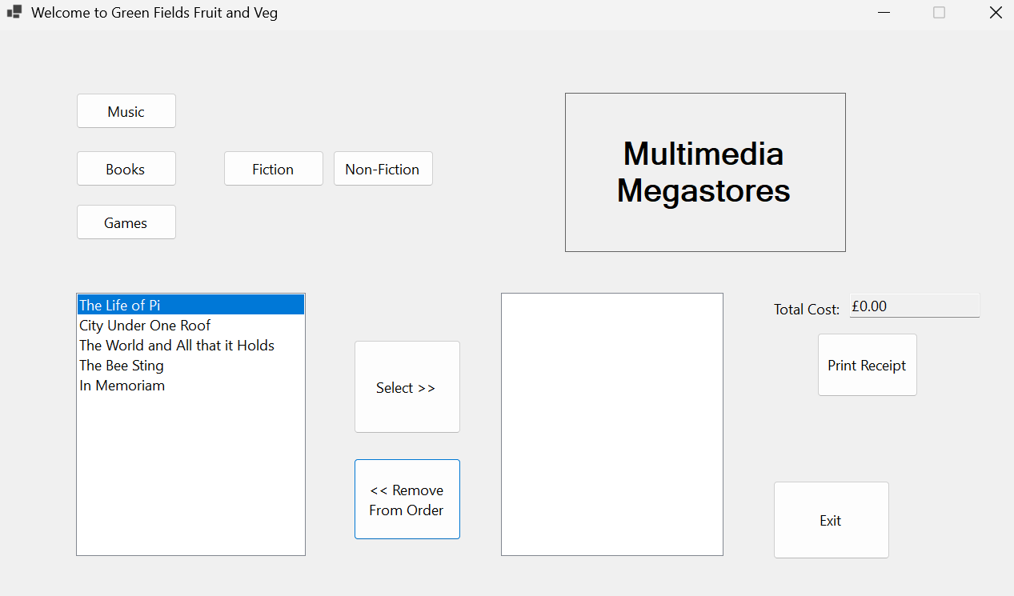
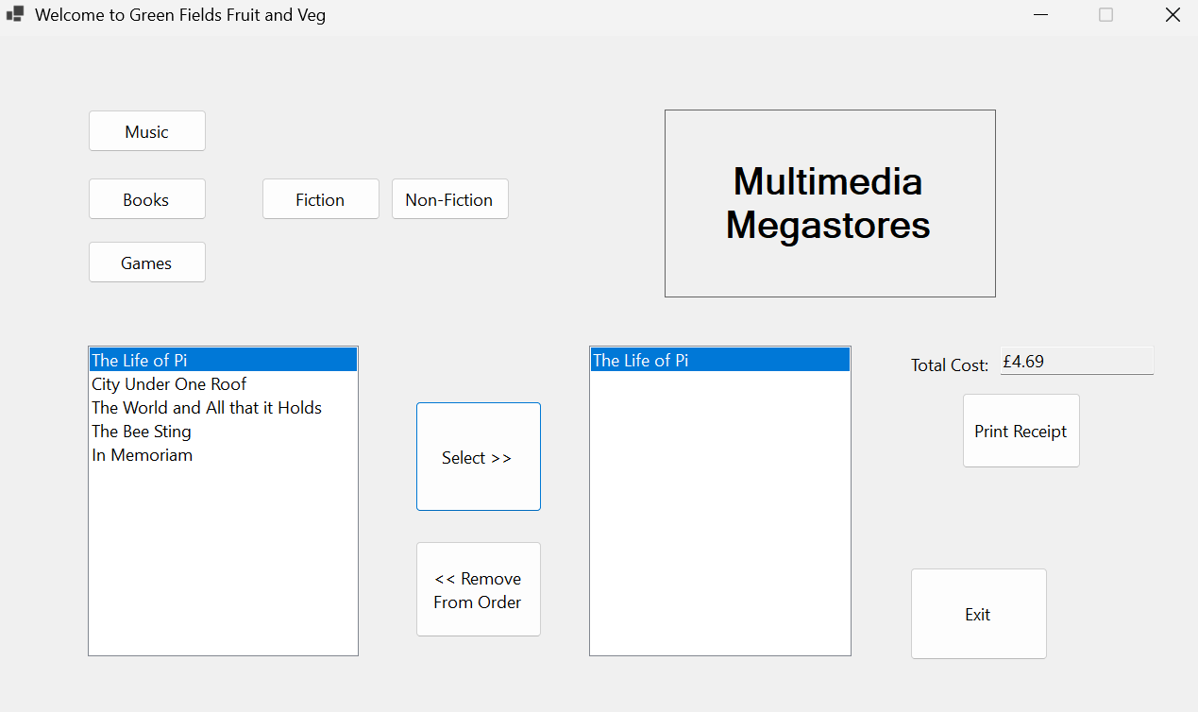

Test Reference: | 3 | Name of Tester: | Archie Tippett |  |  | Date of Test: | 06.10.2026
Purpose of Test: | Can the user select an item from the <<Game>> list, and then add them to an order?
Test Type: | Functional |  |  | User Requirement Tested: | 3
Test Instructions: | Attempt to add items from <<Game>> to an order by clicking on them.
Expected Outcome: | Items are added to the order.
Actual Outcome: | Selecting works.
Pass/Fail/Skipped: | Pass.
Comments and/or  Recommendations: | Removing doesn’t work, it just re-adds the price again. “Playstation” is corrupted.
Evidence:
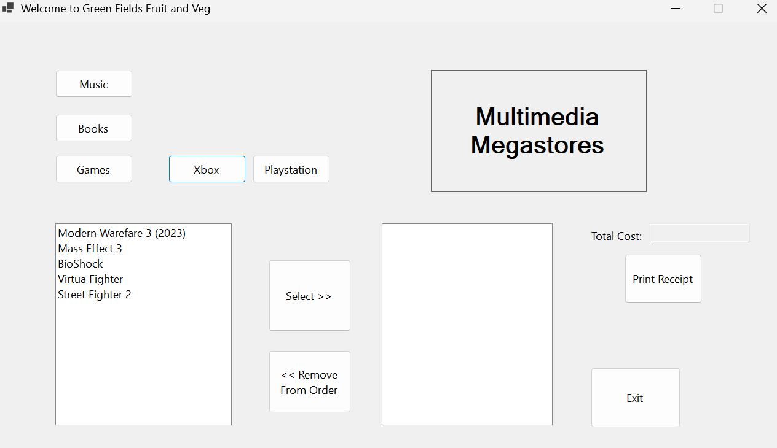

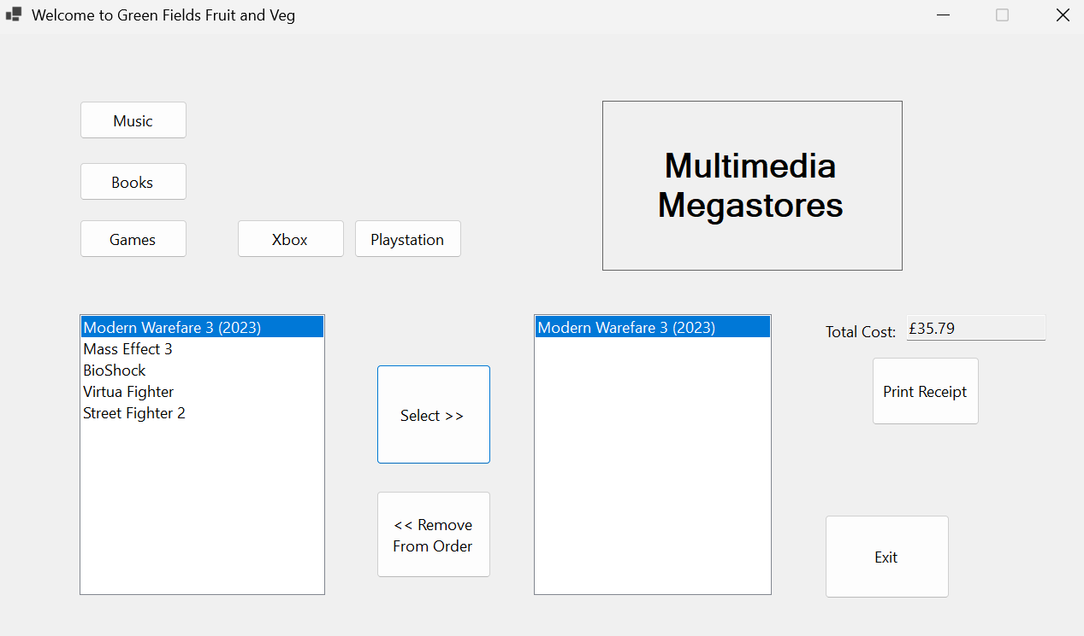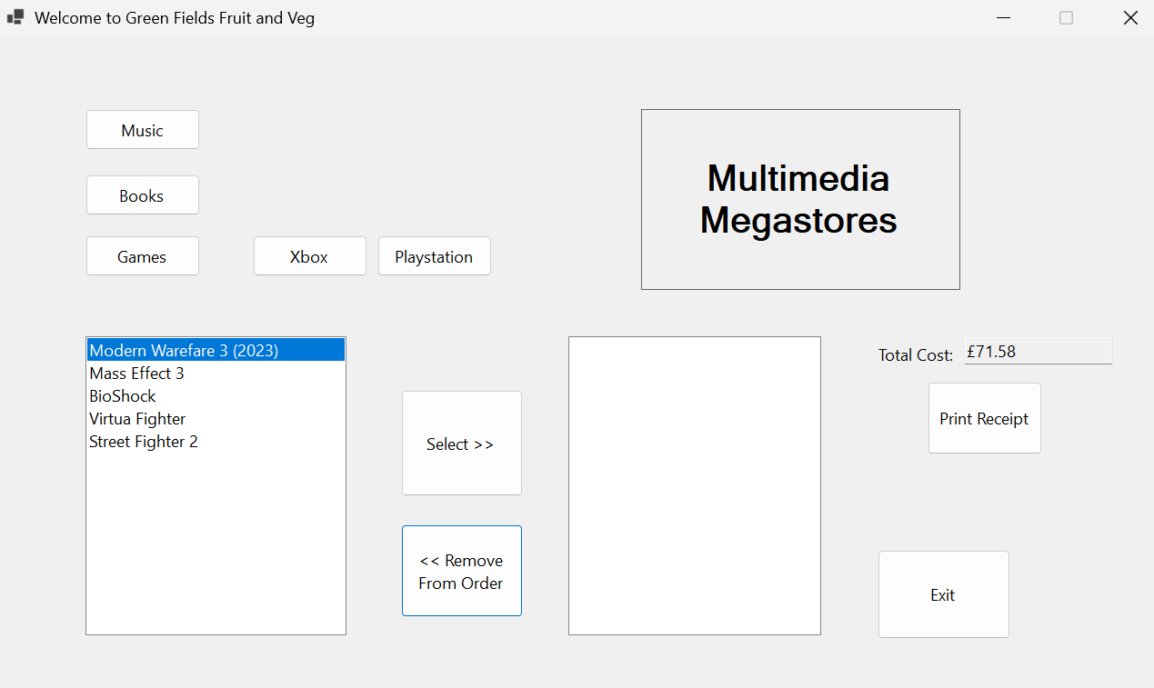
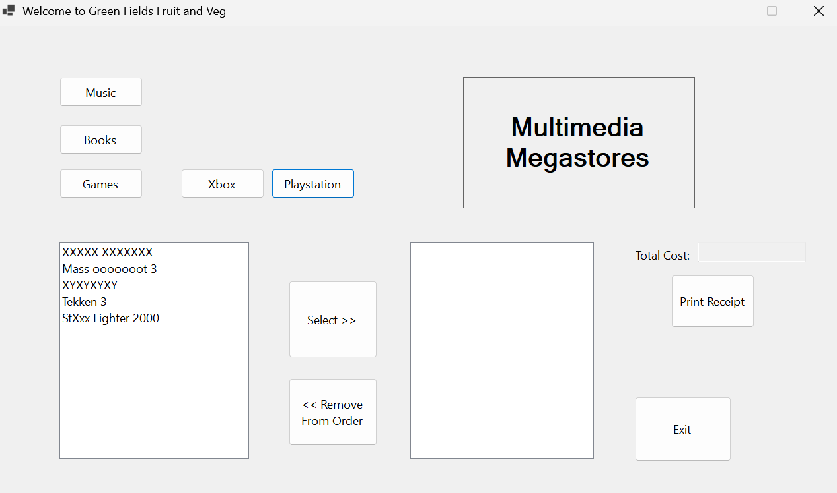

Test Reference: | 4 | Name of Tester: | Archie Tippett |  |  | Date of Test: | 06.10.2026
Purpose of Test: | Is the correct amount for each item being added each time?
Test Type: | Functional |  |  | User Requirement Tested: | 3
Test Instructions: | Attempt to add an item to the order, and see what happens to the <<Total Cost>> number.
Expected Outcome: | The <<Total Cost>> output should update to the correct amount
Actual Outcome: | Works for most, but not for “Games”.
Pass/Fail/Skipped: | Fail
Comments and/or  Recommendations: | Only some work – needs improvement.
Evidence:

Test Reference: | 5 | Name of Tester: | Archie Tippett |  |  | Date of Test: | 06.10.2026
Purpose of Test: | Can the user remove items from the <<order>>?
Test Type: | Functional |  |  | User Requirement Tested: | 5
Test Instructions: | Attempt to remove an item from the <<order>> , and see what happens to the running total.
Expected Outcome: | The <<order>> running total updates correctly.
Actual Outcome: | Only some works, not “Games”.
Pass/Fail/Skipped: | Fail
Comments and/or  Recommendations: | Needs work on “Games”.
Evidence:

